October 3, 2018 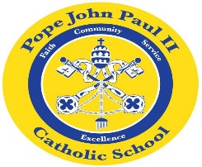
Dear Families of Pope John Paul II Kindergarten Students,
I would like to express my deepest gratitude for your prayers and expressions of sympathy at the loss of my husband of 37 years. While this is difficult for my family, I am comforted in the fact knowing that he is no longer suffering, and that he is at peace in Heaven with God. It is at times like this that we can rely on our faith to help keep us strong. Thank you, again, for all of your support.
In Religion class, the children are learning about stories from the Bible. We compared the story of Jonah and the Whale to Noah’s Ark. The children enjoyed listening to both stories.
In Language Arts classes, we are reading stories about apples and the season of fall. The students are reviewing the various features of books, and they are learning to read from left to right and top to bottom. We are also reviewing the color words. Please look for the Brown Bear, Brown Bear books in next week’s homework folder.
In Math Class, the children are working on the numbers: 0-10, and counting objects.
In Social Studies Class, we are reviewing the rules that we should follow at home, school, etc.
In the days ahead, we will be learning about trees, and leaves in science class. We will also be planting seeds.
As always, please feel free to contact me with any questions or concerns.
REMINDER: Progress Reports go home today. Please sign the attached sheet indicating that you have reviewed the Progress Report, and return to school.

Sincerely,
Colette Flynn

