October 24, 2018 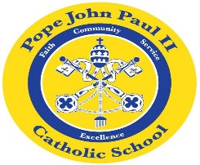
Dear Families of Pope John Paul II Kindergarten Students,
Everything is running smoothly in kindergarten. Thank you so much for your support.
I am sending home a Sight Words Progress Report today. Please review the Progress Report, and sign the attached sheet.
On Halloween Day, October 31, the children may dress up in their costumes. You may provide a candy treat for the class, however, no candy containing peanuts, please!
In Language Arts classes, we are working on the short vowel words, the consonant sounds, and informational texts.
In Math class, we are solving word problems, and counting objects.
In Religion class, the children are learning the Hail Mary, and they are also learning about the Rosary.
In the days ahead, the class will be learning about maps, globes, and planting seeds.
Thank you so much for everything that you do to support your child’s education. As always, please feel free to contact me with any questions or concerns.
Sincerely,
Colette Flynn

