October 10, 2018 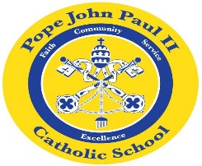
Dear Families of Pope John Paul II Kindergarten Students,
I would like to thank you for giving me the wonderful opportunity to teach your children. I feel truly blessed!
In Religion classes, we are learning about Bible stories. In the days ahead, we will be learning the Hail Mary, and we will also be learning about the Rosary.
In Language Arts classes, the children have been reading The Carrot Seed. The students have also been working on sequencing the events of this story. They really enjoyed this activity. Please look for this story in next week’s homework folder. We have also been working on sounding out the short /a/ words. Please feel free to practice these words at home: at, cat, bat, hat, Pat, rat, sat, can, Dan, fan, Jan, man, ran, pan. We have also been working on the following sight words: and, go, I, is, like, see. Flash cards are a useful tool to help with studying these words.
In Math classes, we have been working on patterns, counting objects and classification. Please ask your child about the “Toys on the Shelf” activity. Through this lesson, the children learned to group objects according to common characteristics.
In Social Studies, the class learned about Johnny Appleseed. In the days ahead, we will be learning about maps and globes.
In Science class, we will be learning about living things.
REMINDER: If you have not yet returned the progress report, please do so as soon as possible.
Once again, thank you for your continued support. As always, please feel free to contact me with any questions or concerns.
Sincerely,
Colette Flynn

