November 7, 2018 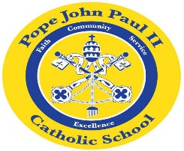
Dear Families of Pope John Paul II Kindergarten Students,
Thank you so much for all of the Halloween Day treats. All of the children had a wonderful time at the various Halloween Day activities.
In Language Arts, we are continuing our study of short /a/ words. Please continue to review these words at home: at, bat, cat, fat, hat, Pat, rat, sat, can, Dan, fan, Jan, man, Nan, pan, ran. Flash cards are a helpful tool to help review these words. Please look for a short /a/ card sorting activity in next Monday’s homework folder. We are also working on main idea and supporting details.
In Math class, we are solving word problems, counting objects and graphs.
In Religion class, we are learning about the importance of prayer.
In Social Studies and Science classes, the children are learning about maps, globes, and the seasons of the year. In the days ahead, we will be planting seeds.
REMINDERS: November 20-Early dismissal (12:00 pm)
Scholastic Book Fair
Parent Teacher Conferences (12:15-3:00 pm and
4:00-7:00 pm)
November 21-23 Thanksgiving Break
Thank you for everything you do to support your child’s education. As always, please feel free to contact me with any questions or concerns.
Sincerely,
Colette Flynn

