November 29, 2017 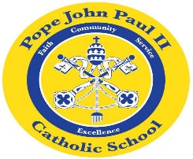
I hope that everyone had a wonderful Thanksgiving holiday. I enjoyed talking with you at Parent-Teacher conferences.
In Religion class, we are learning about the Advent season. This week we will be making Advent wreaths.
In Language Arts, we are studying short /o/. Our spelling test will be Friday, December 1: cot, dot, got, hot, lot. We have also been working on journal writing based on the books which we read in class. The sight words that we are working on include the following: a, about, and, are, be.
In Math class, we are reviewing the numbers: 10-20. We have also started addition and subtraction using word problems.
In Social Studies, the class has been learning about maps.
In preparation for our holiday program, the children are learning about Christmas traditions and songs from Hawaii. More information about the program will follow.
Thank you for everything that you do to support your child’s education. Please feel free to contact me with any questions or concerns.
Sincerely.
Colette Flynn

