November 28, 2018 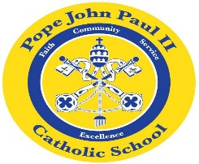
Dear Families of Pope John Paul II Kindergarten Students,
I hope that everyone had a wonderful Thanksgiving Holiday, filled with many blessings.
In language arts classes, we are focusing on the short /e/ sound. Please feel free to review these words at home. Flash cards are a useful tool for this purpose. The book which we are focusing on this week is The Little Red Hen. The students enjoyed answering comprehension questions pertaining to this story. We are also reviewing the short /a/ sound.
In math class, we are continuing our work with word problems and sequencing the numbers: 1 through 10.
In Religion class, we will be discussing Advent. This week, the class will be making Advent Wreaths.
In science and social studies classes, we are continuing our study of living things, maps and globes.
Thank you for everything that you do to support your child’s education. As always, please feel free to contact me with questions or concerns.
Sincerely,
Colette Flynn

