November 14, 2018 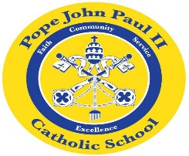
Dear Families of Pope John Paul Kindergarten Students,
I would like to take this opportunity to wish everyone a very happy and blessed Thanksgiving.
This week, we are reviewing the short /a/ sound and the short /e/ sound. We are also focusing on Thanksgiving stories.
In math class, we are working on Thanksgiving word problems and graphs.
In Religion class, we are learning about the importance of prayer.
In the days ahead, we will study living things and various plants.
REMINDERS:
Thursday, November 15-The children may dress up in Disney attire.
Movie on Thursday afternoon-Please send $2
to school for popcorn and water.
November 20-Early dismissal-12:00 pm.
Scholastic Book Fair
Parent Teacher Conferences-12:15-3:00 pm and
4:00-7:00 pm
Please schedule a time for Parent Teacher Conferences
if you have not already done so.
Thanksgiving Break-November 21-23
Once again, have a wonderful Thanksgiving holiday!

Sincerely,
Colette Flynn

