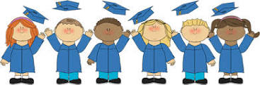

May 15, 2019
Dear Families of Pope John Paul II Kindergarten Students,
It is hard to believe that the end of the year is quickly approaching! Where did the time go?
The children are very excited for their Kindergarten Graduation which will be held on Thursday, June 6 from 12:00 until 1:00. Please arrive in the School Hall by 11:30. Your child should wear his/her Sunday best.
Refreshments will be provided after the Graduation celebration!
The children have been working hard on their songs, and recitations. I look forward to seeing you then.
As always, please feel free to contact me with any questions or concerns.

Sincerely,
Colette Flynn

