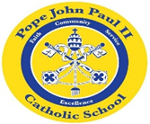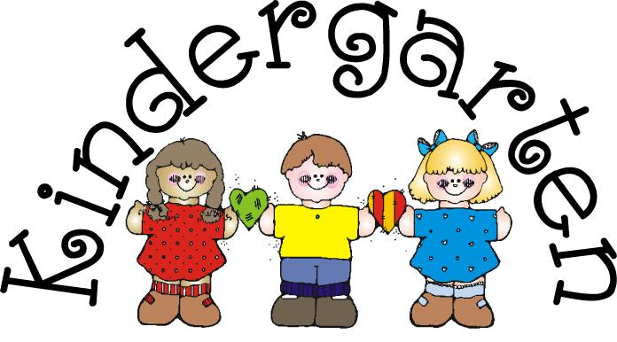

August 20, 2018
Dear Families of Pope John Paul Kindergarten Students,
I am very happy to be your child’s teacher this year. I look forward to presenting many wonderful learning experiences for your child.
Each day, we will be doing Religion, language arts, math, science and social studies activities. During our phonics lessons, your child will be learning the consonant sounds and the vowel sounds. As we focus on the vowel sounds, we will be learning about word families. Your child will bring home a flip book of these words to practice. The children will also be learning sight words this year. Through many different reading opportunities, the class will be working on a variety of comprehension strategies. Calendar, number recognition, counting, place value, and adding and subtracting activities are part of our daily routine. Each Monday, your child will bring home a folder with the completed work from the previous week. The homework packet for the week will also be in the folder. The graded papers on the left side of the folder may remain at home. Please review these papers with your child each week, noting any comments, mistakes, etc. Please feel free to correct the mistakes, and also recognize and praise your child for assignments that are well done.
Your child will bring home a weekly newsletter in the Wednesday folder. This letter will contain the concepts which the children are learning.
Each week, one child will be chosen to be “Star of the Week.” You will be notified when it is your child’s turn. You will be given a very special poster to fill out with your child. The poster will be placed on a special bulletin board, along with pictures of your child.
If you would like to provide a treat for your child’s birthday, cupcakes work best. Please keep in mind that some children are allergic to chocolate and peanuts. For this reason, some vanilla cupcakes would be greatly appreciated. No peanuts, please!
Once again, I thank you for giving me the opportunity to teach your wonderful children. Please feel free to contact me with any questions or concerns. My email address is: cflynn@pjpiischool.org
Also, please feel free to visit my Web Page: http://mrsflynnskindergarten.weebly.com
On this page, you will find weekly newsletters, the homework policy for kindergarten, curriculum, and more.

Sincerely,

Colette M. Flynn

Name of Child: ___________________________
My child’s birthdate: _____________________________
Allergies: __________________________________________________
Is your child allergic to peanuts? ___________________
Is your child allergic to chocolate? __________________

Please list any areas of interest that your child has: hobbies, types of books, favorite TV shows, etc. ____________________________________________________________________________________________________________________________________________________________________________________________________________________________________________________________________________________________________________________________________________________________

