June 5, 2019 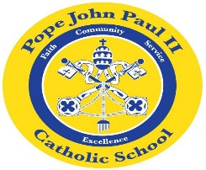
Dear Families of Pope John Paul II Kindergarten Students,
It is hard to believe that another year has come to an end! This year was filled with many wonderful learning experiences for your child, and I am very proud of their progress!
As I was thinking about my 35 years of teaching, I decided that it is time for me to retire. I am planning on spending more time with my grandchildren. This is a bittersweet decision for me because teaching younger children has always been an important part of my life. I will always treasure the memories that I have. Your children have filled my heart with such happiness, and I know that I will miss them. It is, however, time for them to move on to more wonderful and exciting learning adventures.
Thank you so much for all of your support. It is greatly appreciated!
I am looking forward to seeing all of you at the graduation tomorrow.
REMINDERS:
*Please arrive at the School Hall at 11:30 tomorrow, June 6.
*Your child may wear his/her Sunday best.
*The “Shoe Box-Jungle Box” project will be on display at the
graduation ceremony.
Thank you so much for all of your support. I look forward to seeing you tomorrow!
Sincerely,
Colette Flynn

