June 10, 2019 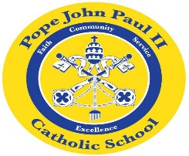
Dear Families of Pope John Paul II Students,
I would like to take this opportunity to express my appreciation and gratitude for all of the beautiful flowers, plants, gift cards, presents, and kind words. It is greatly appreciated.
Thank you, also, for entrusting your wonderful child to me this past year. Your children have made wonderful progress, and I am very proud of them.
Have a very happy and safe summer. I know that First Grade will be a wonderful experience for your child.
Sincerely,
Colette Flynn

