January 9, 2019 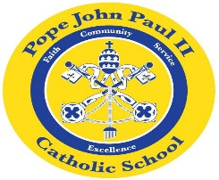
Dear Families of Pope John Paul II Kindergarten Students,
I would like to wish everyone a very happy and Blessed New Year! Thank you so much for all of your prayers, kind words, cards and gifts. It is greatly appreciated!
The New Year is off to a good start in Kindergarten. We are reviewing the short vowel words: SHORT A: bat, cat, fat, hat, Pat, rat, sat, can, Dan, fan, Jan, man, Nan, pan, ran-SHORT E: Ed, bed, fed, red, Ned, Ben, den, hen, men pen, ten,-Short O: cot, dot, got, hot, lot. Please feel free to make flash cards to review these words. Next week, we will be studying the short /i/ words.
We are also reviewing the following sight words: I, and, be, go, is, big, like, see, me, am, he, good, can, come, in, big.
We have also been reviewing the characteristics of informational texts: main idea and supporting details. The children enjoy writing journal entries on the books which we have read as a class. This week, we are learning about the ways in which animals live in the winter months.
In Math, we are solving word problems, and counting various collection of objects up to 20.
REMINDERS: Yesterday, your child brought home a Field Trip Permission Form. Please sign the form and return to school in an envelope marked with your child’s name. The trip is scheduled for Tuesday, January 22.
If you have not yet returned the signature page which was attached to the Sight Words and Short Vowel Words Progress Report, please do so as soon as possible.
Progress Reports will go home on Wednesday, January 16.
Catholic Schools Week begins on Sunday, January 27.
The Science Fair is on Thursday, January 31.
Thank you for everything that you do to support your child’s education!
Sincerely,
Colette Flynn

