January 22, 2019 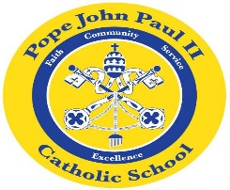
Dear Families of Pope John Paul II Kindergarten Students,
Thank you so much for supporting our field trip to DePaul Theater to see “Go, Dog, Go.” The students had a wonderful time. When we returned to school, the children listened to the story, and they also completed a reading and writing activity based on play. This week, we will continue reading and writing activities based on “Go, Dog, Go.”
In Math, we will continue to work on story problems, and counting activities.
In Science, we are studying the planets. The students are making Planet Books which will be on display at the science fair.
In Social Studies, we are continuing our study of Dr. Martin Luther King.
In Religion, we are learning about how to be helpful and kind to others.
REMINDERS: Registration is open. If you register your child for next year in January, then you will get a discount on the registration fee.
Catholic Schools Week begins January 27.
The Science Fair will be held on Thursday, January 31 from 5:00 until 7:00 P.M.
Thank you very much for all that you do to support your child’s education. As always, please feel free to contact me with any questions or concerns.
Sincerely,
Colette Flynn

