January 16, 2019 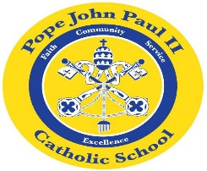
Dear Families of Pope John Paul II Kindergarten Students,
I hope that everyone is having a wonderful start to the New Year!
In Language Arts classes, we are continuing our study of informational texts. This week we are learning about the solar system. The students are very excited to be making books on the solar system. The books will be on display at the Science Fair. We are also working on the short /u/ sound: bun, fun, run, sun. Please feel free to review these words with your child.
In Math class, we are continuing our work on word problems.
In Religion class, we are continuing our study of the birth of Jesus. In the days ahead, we will be learning about ways in which we can help others.
In Social Studies class, we will be studying about the life and times of Dr. Martin Luther King.
Thank you for everything that you do to support your child’s education. As always, please feel free to contact me with any questions or concerns.
REMINDERS: Progress Reports go home today. Please review the Progress Report, and sign the attached signature page. You may keep the Progress Report, but please return the signature page to school by Wednesday, January 23.
Catholic Schools Week begins on Sunday, January 27.
The Science Fair is on Thursday, January 31.
Have a great weekend!
Sincerely,
Colette Flynn

