February 13, 2019 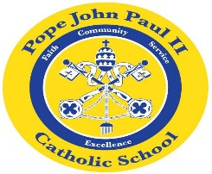
Dear Families of Pope John Paul II Kindergarten Students,
I hope that everyone is staying safe and warm during this time of cold, ice and snow. Also, thank you so much for your participation in our science fair. The students enjoyed learning about the planets, and they enjoyed all of the various activities which we did in class.
In Language Arts, we are continuing to learn about informational texts. The class is also reviewing the short /i/ words: it, bit, fit, hit, lit, pit, sit. Please feel free to review these words at home. We are also reviewing the other short vowel words. In the days ahead, our Language Arts lessons will revolve around Polar Bear, Polar Bear, What Do You Hear? We will also be reading Polar Bear, Polar Bear, What Do You See?
In Math, we are working on graphs and counting collections of various objects.
In the days ahead, we will be learning about dental health. We will also be learning about the Presidents of the United States.
In science class, we will be planting seeds.
In Religion class, the children will become acquainted with the Bible story of the multiplication of the loaves and fish.
Thank you so much for everything that you do to support your child’s education. As always, please feel free to contact me with any questions or concerns.
REMINDERS: On Thursday, February 14, we will have a small Valentine’s Day party. The children may bring Valentines and treats to share with the class. Please keep in mind that all treats should be wrapped. There are 14 students in the class. No peanuts, please!
***No school on Monday, February 18!***
Sincerely,
Colette Flynn

