December 5, 2018 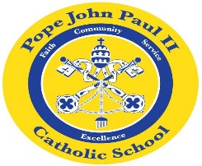
Dear Families of Pope John Paul II Kindergarten Students,
I hope that everyone is taking some time for rest and relaxation during this very busy time of year! The students are very excited and full of anticipation as we approach the Christmas holiday.
In Language Arts classes, the children have been listening to The Elf on the Shelf and The Little Red Pen, as well as other stories related to Christmas. We are continuing to study short vowel /e/ words. In the days ahead, we will be working on the short /o/ sound. We have also been reviewing the following sight words: I, and, be, go, is, big, like, see, me, am, be, he, good, can, come. Please feel free to review these words at home. Flash cards are a useful tool for this purpose. The children have also started journal writing. Their writing is based on the stories which we read in class.
In math class, we are continuing our study of word problems.
In Religion class, we are learning about the birth of Jesus.
In the days ahead, social studies lessons will revolve around holiday customs and traditions.
In science class, we will be learning about fish and other animals that live in the ocean.
REMINDERS: A progress report on the short vowel words and the sight words will go home on Wednesday, December 12. Please review the report, and sign and return the attached signature page.
The Christmas Program is set for Thursday, December 20 at 6:00 pm. More details will follow. There is a 1:00 dismissal on Friday, December 21.
December 24-January 4-Christmas Break
Thank you for giving me the wonderful opportunity to teach your children. As always, please feel free to contact me with any questions or concerns.
Sincerely,
Colette Flynn

