December 12, 2018 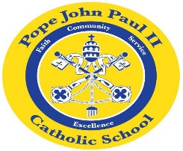
Dear Families of Pope John Paul II Kindergarten Students,
This week the students have been busy reviewing the short vowel words, as well as the sight words. A progress report will be going home today. Please review the progress report, sign and return the attached signature page by Wednesday, December 19.
The Polar Express Pajama Party is scheduled for Wednesday, December 19. Wear your pajamas to school (no slippers). Bring a blanket, pillow, or a sleeping bag and camp out in the hall from 1:00-3:00 while watching the Polar Express and enjoying cookies and milk.
Our Christmas Program is set for Thursday, December 20 at 6:00 P.M. Please have your child dress in their Sunday best. Also, I am asking each child to wear a winter hat, mittens, and a scarf for the Christmas program. More details will follow.
On Thursday, December 20, the children will be participating in a Christmas ugly sweater/t-shirt contest. Please bring in $1.00 to wear an ugly sweater/t-shirt to school. There will be a contest in each homeroom to determine which seater or t-shirt is the “ugliest.” (most creative). One prize will be awarded in each homeroom.
On Friday, December 21, there will be a 1:00 P.M. dismissal.
Christmas Break is from December 24-January 4.
As always, please feel free to contact me with any questions or concerns.
Sincerely,
Colette Flynn

