August 20, 2018 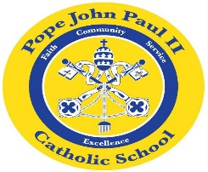
Dear Families of Kindergarten Students of Pope John Paul II School,

I hope that everyone had a wonderful summer filled with relaxation, family time and many learning experiences.
My name is Colette Flynn, and I am delighted to be your child’s teacher this year. Many of you may know me from the Title I Program.
I have been teaching in the Archdiocese of Chicago for over thirty years. I reside in Evergreen Park with my husband of thirty-seven years. My older daughter is married, and she has two beautiful boys. My younger daughter is also married, and she is a Ph.D. candidate from Southern University. She has a brand new baby girl: Lillian Rachel. I am a proud Grandma.
I received my M.A. in education from Saint Xavier University. The focus of my studies involved researching the individual and unique learning styles of children. It was a wonderful experience, and I am so happy that I continued my education.
One of my goals this year is to provide a wide range of learning experiences for your wonderful children. You will be kept informed of the kindergarten curriculum which your children are studying via weekly newsletters. However, if you have any questions or concerns, please feel free to contact me through email, a phone call, or come see me in person.
Thank you for giving me the wonderful opportunity to teach your beautiful children. I look forward to working with you to ensure that your child receives an education filled with knowledge and excitement for learning.
Sincerely,

Colette M. Flynn

